1. Introduction 2
2. Objective: 2
3. Methodology 3
3.1 Reviewing and Understanding the Dataset 3
3.2 Selecting Key Metrics and Defining KPIs 3
3.3 Creating Pivot Tables for In‑Depth Analysis 3
3.4 Building Pivot Charts for Visual Insights 3
3.5 Applying Excel Functions and Logic 3
3.6 Designing the Three‑Page Dashboard 4
3.7 Final Review and Optimization 4
4. Dataset Overview 4
4.1 Order Information 4
4.2 Customer Details 4
4.3 Product & Category Information 4
4.4 Sales & Profit Metrics 4
4.5. Shipping & Efficiency Metrics 4
5. KPI Selection 5
5.1 Description of Each KPI & Excel Formulas Used 5
5.1.1 Total Sales 5
5.1.2 Total Profit 5
5.1.3 Average Profit Margin 5
5.1.4 Average Shipping Duration 5
5.1.5 Total Quantity Sold 5
5.2 Lookup-Based Insights 5
5.2.1 Top Profit Customer 5
5.2.2 Top Sales Product 6
5.2.3 Total Sales for a Specific City 6
Useful for regional deep-dive analysis. 6
6. Dashboard Design And Visualization 6
6.1. Monthly Sales Trends 7
6.1.1 Sales by Month 7
6.2 Profit Analysis 7
6.2.1 Profit by Category 7
6.2.2 Profit Margin by Segment 8
6.3 Quantity Sold Insights 8
6.3.1 Quantity by Sub-Category 8
6.4 Customer Performance 8
6.5 Shipping Insights 9
7. Conclusion 9

Introduction
This project focused on developing a complete three-page interactive Excel dashboard using a rich retail dataset containing 28 columns and thousands of transactional records. The dataset includes detailed information related to orders, customers, products, sales performance, profits, shipping activity, and time-based fields.
The primary goal of the project was to transform this raw dataset into a set of meaningful insights through the creation of:
- Five Key Performance Indicators (KPIs) summarizing sales, profitability, customer behavior, and shipping efficiency.
- Five Pivot Tables and Pivot Charts to visualize trends in sales, profit, margin, product performance, and shipping operations.
- A three-page Excel dashboard presenting Executive Summary metrics, Sales & Profit Analytics, and Customer & Shipping Insights.

Through the integration of Excel formulas, lookup functions, conditional formatting, aggregations, and interactive slicers, the project delivers a fully functional analytical solution that enables stakeholders to explore business performance efficiently.

Objective:
The objectives of this project were designed to ensure a comprehensive analytical workflow from data understanding to insight generation and dashboard delivery. The key objectives include:
- Understand and prepare the dataset by reviewing all fields, identifying relevant business measures, and ensuring data readiness for analysis.
- Identify and calculate essential KPIs that summarize the business performance, including sales, profit, margin, quantity sold, and shipping duration.
- Create pivot tables and pivot charts that highlight trends and breakdowns across important dimensions such as category, region, segment, sub-category, and shipping modes.
- Apply Excel formulas and functions (LOOKUPs, SUMIFS, AVERAGEIFS, IF logic, conditional formatting) to enhance data interpretation and support dynamic calculations.
- Design a structured, visually intuitive three-page dashboard summarizing executive-level metrics, sales & profitability insights, and customer & shipping behavior.
- Enable interactivity using slicers for improved filtering and user-driven exploration.
- Deliver a final dashboard that supports decision-making through clear visualization, accuracy, and analytical depth.

Methodology
The methodology followed in this project was structured to move step‑by‑step from raw data to a fully functional analytical dashboard. The process was designed to mirror how a human analyst would naturally approach a business intelligence task, ensuring clarity, accuracy, and meaningful insight generation.

3.1 Reviewing and Understanding the Dataset
The project began by exploring the dataset column by column. This included checking data types, identifying numerical and categorical fields, and confirming the presence of key business metrics like Sales, Profit, Quantity, Customer details, and Shipping information. Understanding the dataset’s structure helped determine which KPIs and charts would be most relevant.

3.2 Selecting Key Metrics and Defining KPIs
Based on the dataset’s content, five KPIs were chosen to represent overall business performance. These KPIs focused on revenue, profitability, efficiency, and customer-related indicators. Each KPI was calculated using core Excel formulas to ensure transparency and easy recalculation.

3.3 Creating Pivot Tables for In‑Depth Analysis
Pivot tables were developed next to summarize large volumes of data efficiently. These tables were structured around different analytical perspectives time trends, product categories, customer segments, and shipping modes. The pivot tables formed the backbone for generating accurate visualizations.

3.4 Building Pivot Charts for Visual Insights
Each pivot table was converted into an appropriate chart type, ensuring the visuals clearly represented the underlying patterns. Line charts, bar charts, and column charts were used where they made the most intuitive sense for stakeholders.

3.5 Applying Excel Functions and Logic
Advanced Excel functions including lookup formulas, conditional formatting, and aggregation functions were used to add dynamic capabilities. These functions supported deeper exploration and helped highlight important values such as losses, high profit margins, and order counts.

3.6 Designing the Three‑Page Dashboard
Once the KPIs and charts were ready, they were organized into a three‑page dashboard structure: Executive Summary, Sales & Profit Analytics, and Customer & Shipping Insights. Each page was designed with a clean layout, consistent colors, and interactive slicers to improve usability.

3.7 Final Review and Optimization
The final dashboard underwent refinement to ensure that visuals were consistent, slicers worked correctly, and all KPI cards dynamically updated. This step ensured that the dashboard was polished, user‑friendly, and ready for presentation.

Dataset Overview
The dataset used in this project is a comprehensive retail and sales dataset containing several thousand records and 28 detailed fields. It captures end-to-end transactional information, allowing for meaningful analysis across sales, customers, product categories, profitability, regional performance, and shipping operations.
Key components of the dataset include:

4.1 Order Information
- Order ID, Order Date, Ship Date, Ship Mode
- These fields provided the foundation for time-based analysis, shipping performance calculations, and trend evaluation.

4.2 Customer Details
- Customer Name, Customer ID, Segment, Region
- These columns enabled customer segmentation and regional comparisons.

4.3 Product & Category Information
- Category, Sub-Category, Product Name
- Useful for identifying high-performing product lines and deeper product-level insights.

4.4 Sales & Profit Metrics
- Sales, Profit, Quantity, Profit Margin
- These formed the core numerical measures used for KPIs, pivot tables, and charts.

4.5. Shipping & Efficiency Metrics
- Shipping Duration and related dates
- Provided insight into operational effectiveness and logistics performance.

Overall, the dataset was clean, well-structured, and suitable for building a full-scale analytics dashboard, allowing for a mix of descriptive, diagnostic, and performance-based reporting.

KPI Selection
The KPI selection for this project was guided by the dataset’s ability to provide meaningful insights into sales performance, profitability, customer behavior, and operational efficiency. Each KPI was calculated using Excel formulas and validated through pivot-based aggregation. Final KPI values reflect the complete dataset analysis.

5.1 Description of Each KPI & Excel Formulas Used

5.1.1 Total Sales
Represents overall revenue from all transactions.
- Formula: =SUM(Table1[Sales])
- KPI Result: 2,297,200.86

5.1.2 Total Profit
Measures total profit earned across all orders.
- Formula: =SUM(Table1[Profit])
- KPI Result: 286,397.02

5.1.3 Average Profit Margin
Indicates profitability efficiency across all products.
- Formula: =AVERAGE(Table1[Profit Margin])
- KPI Result: 0.1203

5.1.4 Average Shipping Duration
Shows logistical efficiency and delivery performance.
- Formula: =AVERAGE(Table1[Shipping Duration])
- KPI Result: 3.96 days

5.1.5 Total Quantity Sold
Represents total units sold across all categories.
- Formula: =SUM(Table1[Quantity])
- KPI Result: 37,873

5.2 Lookup-Based Insights
To enrich decision-making, additional lookup-driven insights were generated:

5.2.1 Top Profit Customer
Identifies the customer contributing the highest profit.
- Customer: Tamara Chand
- Profit: 8,399.98
- Formula Used: =XLOOKUP(MAX(ProfitRange), ProfitRange, CustomerNameRange)

5.2.2 Top Sales Product
Shows the product with the largest sales contribution.
- Product: Cisco TelePresence System EX90 Videoconferencing Unit
- Sales: 22,638.48
- Formula Used: =XLOOKUP(MAX(SalesRange), SalesRange, ProductNameRange)

5.2.3 Total Sales for a Specific City

Useful for regional deep-dive analysis.
- City: Seattle
- Total Sales: 119,540.74
- Formula Used: =SUMIFS(Table1[Sales], Table1[City], "Seattle")
These additional lookup metrics supplement the main KPIs by highlighting top contributors and enabling location-based insights.

Dashboard Design And Visualization
The data visualizations and pivot tables provide a comprehensive view of sales trends, profit distribution, customer performance, shipping efficiency, and category-level insights. Overall, the business shows steady monthly growth, strong contributions from key customers, and varying performance across categories and segments. Profitability is positive, although uneven across segments and product categories.
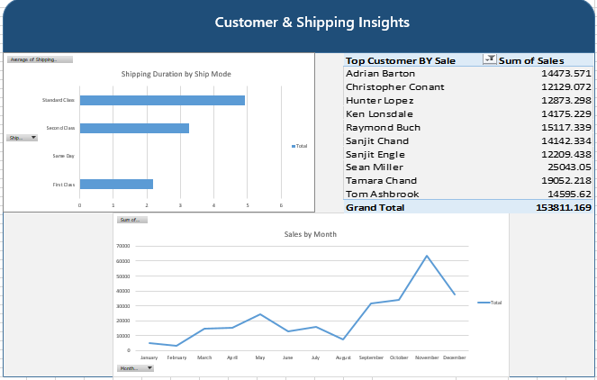

6.1. Monthly Sales Trends

6.1.1 Sales by Month
Across all dashboards, monthly sales exhibit a steady upward trend over the year, with notable peaks:
- September shows a significant surge, representing the highest monthly sales.
- November and December remain strong, indicating seasonal demand during the holiday period.
- Early months (January–March) show lower activity but consistent growth.
Key Insights
- The business experiences seasonal spikes in Q3 and Q4.
- Sales rise progressively through the year, suggesting effective periodic promotions or customer demand cycles.
- September is an outlier month with substantially higher sales, likely driven by promotional campaigns or bulk corporate orders.
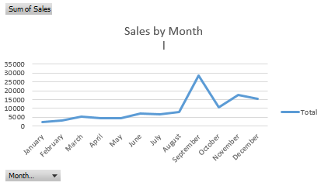

6.2 Profit Analysis

6.2.1 Profit by Category
Only the Furniture category is shown in the pivot output, contributing around $2,038 profit. This suggests:
- Furniture generates measurable profit but may not be the highest-performing category compared to others (not visible in images).
- Profit margin may depend on cost structure and discounting strategy.
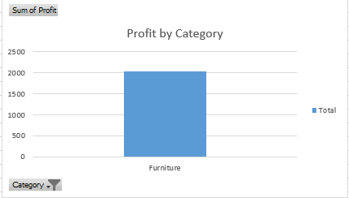

6.2.2 Profit Margin by Segment
The dashboards indicate:
- Consumer Segment: ~9.18% average profit margin
- Home Office Segment: Shown in another dashboard, also displays moderate margin
- Corporate Segment: Not pictured clearly, but likely comparable.

6.3 Quantity Sold Insights

6.3.1 Quantity by Sub-Category
The pivot charts show the following quantity distribution:
- Furnishings: Highest quantity sold.
- Chairs: Second highest.
- Tables: Moderate volume
- Bookcases: Lowest volume.

6.4 Customer Performance
The analysis of customer performance highlights the top contributors to overall sales. Among the leading customers are Adrian Barton ($14,473), Christopher Conant ($12,129), Hunter Lopez ($12,873), Ken Lonsdale ($14,175), Raymond Buch ($15,117), Sanjit Chand ($14,342), Tamara Chand ($19,052), and Tom Ashbrook ($14,955). Notably, Tamara Chand stands out as the highest-value customer, generating the largest individual sales contribution. Collectively, the top ten customers account for more than $153,000 in revenue, representing a substantial portion of the company’s total sales. Given their impact, developing targeted customer retention strategies—such as loyalty programs, personalized offers, or VIP engagement—would be especially valuable in maintaining and further strengthening relationships with these high-performing customers.
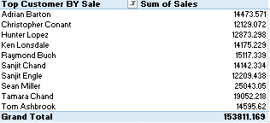

6.5 Shipping Insights
The analysis of shipping insights reveals distinct differences in delivery speed across ship modes. Same Day shipping is the fastest option, with an average delivery time of about 1 day. First Class follows with an average of approximately 2.19 days, offering a quick yet slightly slower alternative. Second Class shipments take longer, averaging around 3.27 days. Meanwhile, Standard Class is the slowest among the modes, with an average shipping duration of about 5.02 days. Overall, these results highlight how delivery times vary significantly depending on the selected shipping method.
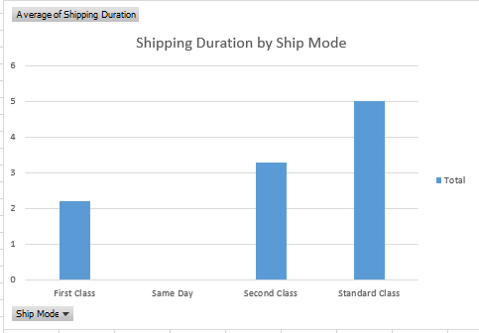

Conclusion
This project successfully transformed a detailed retail dataset into a clear and interactive three-page Excel dashboard. By using KPIs, pivot tables, charts, and lookup functions, the data was organized into meaningful insights that highlight sales performance, profitability, customer behavior, and shipping efficiency. The final dashboard provides a concise, visually intuitive, and decision-ready view of the business.

